Mixed Integer Linear Programming Model for Cost and Carbon Aware LPG Vessel Speed Optimization under Terminal Congestion

Dimas Kunto Wibisono^{1*}, Beni Cahyono², Semin³ Muhammad Revanza Maulana⁴
(Received: 20 July 2026 / Revised: 22 July 2026 / Accepted: 25 July 2026 / Available Online: 10 September 2026)

Abstract⎯ Port congestion has become one of the major operational challenges in LPG logistics because it increases vessel waiting time, bunker consumption, operating costs, and greenhouse gas emissions. Conventional congestion mitigation often relies on infrastructure expansion, which requires substantial investment and long implementation periods. This study aims to develop a Mixed Integer Linear Programming (MILP) model that synchronizes LPG vessel arrival with jetty availability through optimal vessel speed selection to minimize bunker costs while reducing carbon emissions. A MILP optimization model was developed using operational data from Terminal LPG Tanjung Sekong, Indonesia. The model incorporates jetty capacity, vessel schedules, sailing time, processing time, fuel consumption, bunker prices, and vessel compatibility constraints to determine whether each vessel should operate at service speed or slow-steaming speed. Results show that the proposed model reduces bunker costs by USD 46,675/month, decreases jetty waiting time by 3.26 days/month, and lowers carbon emissions by 221.7 tCO₂/month. These findings demonstrate that synchronizing vessel arrival with terminal readiness provides a practical operational alternative to infrastructure expansion while supporting maritime decarbonization.

Keywords⎯ Vessel speed optimization, slow-steaming, MILP, port congestion, bunker cost, carbon emissions.’

*Corresponding Author: dimas.k.wibisono@gmail.com

- introduction
Maritime transportation plays a fundamental role in global supply chains by facilitating the movement of commodities across regions. The distribution of liquefied petroleum gas (LPG) relies heavily on maritime logistics, making efficient vessel scheduling an important factor in maintaining supply reliability. However, the continuous growth in maritime transportation demand has intensified operational pressure on ports and terminals because vessel arrivals are increasing faster than available handling capacity [1], [2]. This imbalance frequently creates berth congestion, resulting in extended waiting times for vessels and reduced terminal operational performance [3].
Waiting time has become one of the major sources of operational inefficiency in port and terminal operations. During this period, vessels continue consuming fuel to support onboard operations while awaiting berth availability, leading to additional bunker costs [4]. Besides increasing operational expenses, prolonged waiting time also contributes to higher greenhouse gas emissions from the maritime sector [5]. Consequently, reducing unnecessary waiting time has become increasingly important not only from an economic perspective but also as part of the maritime industry's commitment toward decarbonization.
____________________________________

Dimas Kunto Wibisono, Department of Marine Engineering, Institut Teknologi Sepuluh Nopember, Surabaya, 60111, Indonesia, E-mail: dimas.k.wibisono@gmail.com
Beny Cahyono, Department of Marine Engineering, Institut Teknologi Sepuluh Nopember, Surabaya, 60111, Indonesia, E-mail: beny@its.ac.id
Semin, Department of Marine Engineering, Institut Teknologi Sepuluh Nopember, Surabaya, 60111, Indonesia, E-mail: seminits@gmail.com.
Muhammad Revanza Maulana, Gas Shipping Operation, Pertamina Patra Niaga, 10110, Jakarta, E-mail : muhammad.maulana8@pertamina.com

Various approaches have been proposed to improve port efficiency. Infrastructure expansion, such as increasing berth capacity or developing additional terminal facilities, can reduce congestion but generally requires substantial investment and long implementation periods [6]. As an alternative, operational planning strategies have attracted increasing attention because they can improve system performance without requiring significant physical expansion. One of the most widely studied approaches is vessel speed optimization, where vessel speed is adjusted to better synchronize vessel arrival with operational conditions at the destination port or terminal.
Previous research has examined vessel speed optimization across a broad range of maritime operational settings. Initial studies primarily focused on incorporating sailing speed into ship scheduling and shipping service planning models [7], [8]. Later research extended this concept to support decision-making in berth allocation, terminal operations, port management, and congestion mitigation by integrating vessel speed with port-related activities [9], [11]. More recently, researchers have adopted multi-objective optimization approaches that evaluate operational cost, fuel consumption, carbon emissions, and service quality within a unified optimization framework [12]. Collectively, these findings suggest that the role and application of vessel speed optimization are shaped by the characteristics and requirements of the operational environment.
Despite the extensive development of vessel speed optimization models, existing studies are generally developed under operational environments that differ from LPG terminal operations. Many studies assume flexible sailing schedules, integrated berth planning, or dynamic port management decisions. However, LPG terminals commonly operate under predetermined vessel schedules, fixed service sequences, and limited berthing facilities, where excessive waiting time primarily results from the mismatch between vessel arrival time and jetty availability. Under these operational characteristics, vessel speed adjustment serves as an operational strategy to synchronize vessel arrival with terminal readiness rather than as an isolated optimization problem.
Although slow steaming has been extensively studied, most previous research assumes flexible berth allocation or integrated port scheduling. However, LPG terminals operate under fixed schedules, limited jetty capacity, and strict operational procedures. Consequently, existing models cannot be directly applied to LPG terminal operations, creating a gap between optimization theory and industrial practice.
This study addresses the following research question: How can vessel speed be adjusted to synchronize vessel arrival with jetty availability in order to minimize bunker cost while reducing carbon emissions in LPG terminal operations? To answer this question, this study develops a Mixed Integer Linear Programming (MILP) model to determine the optimal vessel speed alternatives for LPG vessels operating at Terminal LPG Tanjung Sekong. The proposed model explicitly incorporates operational characteristics of the terminal, including vessel schedules, processing time, jetty availability, fuel consumption, and bunker costs. In addition, the optimized operational schedule is used to estimate the potential reduction in carbon emissions achieved through the implementation of slow steaming. The findings are expected to provide practical decision support for terminal operators while demonstrating how operational speed adjustment can simultaneously improve operational efficiency and contribute to maritime decarbonization.
The novelty of this study lies in:
- developing a MILP model specifically for LPG terminals;
- integrating vessel speed optimization with jetty availability constraints;
- simultaneously minimizing bunker cost and estimating carbon reduction;
- proposing the Vessel Speed Decision Support Framework (VSDSF) for operational implementation.

- literature review
- Vessel Speed Optimization
Vessel speed optimization is the process of selecting an appropriate sailing speed that enables a vessel to meet predefined operational objectives within maritime transportation systems [13]. Because sailing speed can be adjusted during voyage planning, optimization models commonly define it as a decision variable. Variations in vessel speed influence travel time, fuel consumption, operating expenses, estimated arrival time, and the utilization of port and terminal resources [10]. For this reason, optimizing vessel speed has become a widely adopted approach to enhancing both the operational efficiency and environmental sustainability of maritime logistics systems [14].
The goals of vessel speed optimization are influenced by the specific operational conditions and decision-making requirements addressed in individual studies. Within maritime transportation, optimization models are commonly developed to reduce fuel consumption, bunker expenditure, overall operating costs, schedule disruptions, delays resulting from port congestion, and carbon emissions [10]. In addition, several studies have adopted multi-objective formulations that evaluate economic efficiency, service quality, and environmental performance simultaneously [12]. These diverse applications demonstrate that vessel speed optimization has evolved beyond a fuel-saving strategy into a comprehensive decision-support framework capable of improving operational efficiency while advancing sustainability goals
Early studies primarily investigated vessel speed optimization from the perspective of ship scheduling and shipping service planning [7], [8]. In these studies, speed decisions were mainly used to satisfy sailing schedules while minimizing operating costs or improving fleet utilization. The optimization process focused on determining appropriate sailing speeds that balance schedule feasibility and transportation efficiency.
As research progressed, vessel speed optimization began to be integrated into broader port and terminal operations. Instead of considering sailing activities independently, subsequent studies incorporated vessel speed decisions together with berth allocation, quay crane assignment, and terminal resource planning [9]–[11]. This integration enables vessel arrivals to be coordinated with terminal readiness, leading to improved utilization of port facilities and reduced operational inefficiencies.
More recent studies further expanded vessel speed optimization into more complex operational environments. Vessel speed has been incorporated into congestion management strategies to reduce delays caused by port congestion and has also become part of multi-objective optimization models that simultaneously consider operational cost, fuel consumption, carbon emissions, and service quality [12]. These developments demonstrate that vessel speed optimization has gradually evolved from an isolated scheduling problem into an integrated decision-making component within maritime logistics systems.
Although these studies investigate vessel speed optimization under different operational settings, they consistently indicate that the effectiveness of speed decisions depends heavily on the operational environment in which they are implemented. Consequently, understanding the characteristics of the operational environment becomes essential before developing an optimization model for a particular maritime application.

- Research Gap
Despite the significant development of vessel speed optimization, previous studies have been developed under decision environments that differ considerably from LPG terminal operations. Existing studies commonly formulate speed decisions within the context of ship scheduling, fleet planning, integrated terminal operations, berth allocation, or port congestion management. These operational environments generally assume flexible operational planning in which multiple decisions can be optimized simultaneously.
Table 1
Research Gap Comparison Table
Author | Objective | Method | Limitation | Gap
Yu et al (2022) | Terminal Efficiency | Integrated Optimization | Container terminal | Not LPG Environment, No Emission calculation
Guo et al.  (2024) | Schedule reliability | Optimization  Model | General port | Not LPG Environment, No Emission calculation
Wen et al. (2024) | Total Cost | Multi-objective Optimization | Maritime System Transportation | Not LPG environment, not deep in operational aspect
This study | Total Cost & Emission Reduction | MILP | LPG Port | New contribution

In contrast, LPG terminal operations are characterized by predetermined vessel schedules, fixed processing sequences, limited jetty capacity, and relatively deterministic operational procedures. Under these conditions, waiting time mainly arises from the mismatch between vessel arrival time and jetty availability rather than from dynamic congestion or berth allocation decisions. Therefore, the role of vessel speed shifts from optimizing an entire transportation network toward synchronizing vessel arrival with terminal readiness.
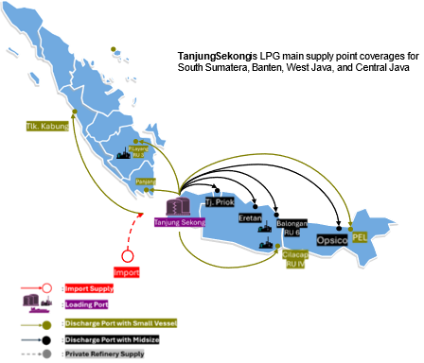
Figure 1 Terminal LPG Tanjung Sekong Distribution Network
Based on these operational characteristics, this study formulates vessel speed optimization as an operational planning problem in which alternative sailing speeds are determined to reduce waiting time before berthing while minimizing bunker costs. Furthermore, since bunker consumption directly contributes to carbon emissions, the optimized operational schedule is also evaluated in terms of its potential environmental benefits through emission reduction. This decision distinguishes the present study from previous research while maintaining the fundamental concept of vessel speed optimization as the primary operational decision.
- case study
Tanjung Sekong LPG Terminal serves as a critical logistics hub within Indonesia's LPG distribution system, handling the receipt, storage, and redistribution of LPG delivered from domestic refineries and import sources (Figure 1). The terminal supplies receiving terminals throughout Southern Sumatra, Western Java, and Central Java, while maintaining nearly 35–40% of the national LPG inventory. Owing to its strategic role, efficient terminal operations are fundamental to sustaining a secure and uninterrupted LPG distribution network
The transfer of LPG distribution services from STS Teluk Semangka has resulted in a notable rise in vessel movements at Tanjung Sekong LPG Terminal. This increase has intensified the use of critical terminal resources, including berths, storage tanks, and jetty facilities. Since infrastructure capacity has remained largely unchanged, berth congestion has become increasingly common, with vessel waiting time emerging as a key operational issue that affects terminal performance.
Operational records indicate that vessel waiting time at the terminal is primarily caused by two factors: next employment (39%) and jetty availability (26%) (Figure 2). Although next employment represents the largest contributor, it is mainly determined by external operational decisions, including cargo readiness at the next destination and downstream distribution planning.
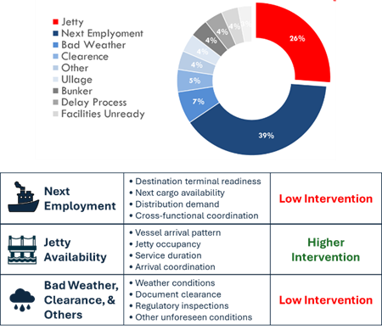
Figure 2. Drivers of Port Congestion at the Tanjung Sekong LPG Terminal
Consequently, opportunities for operational improvement from the terminal perspective remain limited. In contrast, waiting time associated with jetty availability is directly related to terminal operations and can potentially be reduced through better synchronization between vessel arrival and terminal readiness.
Several alternatives may be considered to reduce jetty-related waiting time (Figure 2). Expanding terminal infrastructure by constructing additional jetties can increase handling capacity but requires substantial capital investment and long implementation periods. Modifying the master vessel schedule may improve berth utilization but could disrupt upstream supply planning and downstream material balance. Improvements in loading and unloading activities are also constrained by strict safety regulations and fixed operational procedures governing LPG handling. Therefore, among the available alternatives, vessel speed adjustment before arrival represents the most practical operational intervention because it can improve the synchronization between vessel arrival time and jetty availability without requiring infrastructure expansion or changes to the existing distribution schedule.
Nevertheless, vessel speed adjustment should not be implemented independently. Excessive speed reduction may increase sailing time and fuel consumption during the voyage, while insufficient speed adjustment may cause vessels to arrive before the jetty becomes available, resulting in unnecessary waiting time. Therefore, determining an appropriate vessel speed requires consideration of multiple operational factors, including vessel schedules, sailing time, processing time, jetty availability, waiting time, bunker consumption, and bunker cost. Since fuel consumption is directly associated with carbon emissions, vessel speed decisions also influence the environmental performance of terminal operations.
To address this operational problem, it is first necessary to understand how these operational factors interact within the terminal system. Therefore, an influence diagram is developed to represent the causal relationships among the key operational elements involved in LPG vessel operations at Terminal LPG Tanjung Sekong (Figure 3). As illustrated in the influence diagram, vessel speed is determined based on the planned vessel schedule while considering the expected availability of the destination jetty. Once the speed is selected, it determines the sailing time, which subsequently affects the Estimated Time of Arrival (ETA). The resulting ETA is then compared with the actual jetty availability, which is influenced by the completion of ongoing loading and unloading activities and is therefore dependent on the processing time of vessels with different characteristics. If a vessel arrives before the jetty becomes available, waiting time is generated before berth.
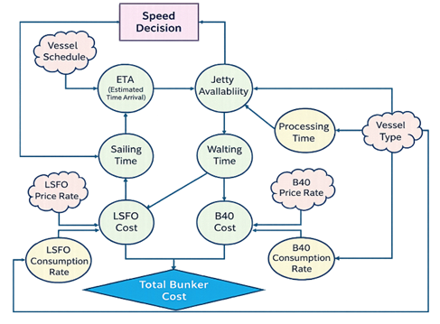
Figure 3 Influence Diagram from Terminal LPG Tanjung Sekong System Element

The influence diagram further distinguishes fuel consumption into two operational phases. During the sailing phase, LSFO consumption is determined by the sailing time, fuel consumption rate, and prevailing LSFO price. During the waiting phase, the vessel consumes B40 fuel while operating auxiliary engines before berthing, with the corresponding bunker cost determined by the waiting time, B40 consumption rate, and prevailing B40 price. The total bunker cost is therefore obtained by combining fuel costs incurred during both sailing and waiting activities. This causal structure reveals the fundamental trade-off addressed in this study: reducing sailing speed may decrease waiting time but increase fuel consumption during the voyage, whereas increasing sailing speed may shorten the voyage but result in higher waiting time and additional fuel consumption at the terminal. Building upon this conceptual representation, a Mixed Integer Linear Programming (MILP) model is developed to determine alternative vessel speeds that synchronize vessel arrival with jetty availability, thereby minimizing total bunker cost while estimating the potential reduction in carbon emissions resulting from the implementation of slow steaming. The proposed model is expected to provide a practical decision-support tool for terminal operators to improve operational efficiency while supporting environmental sustainability objectives within LPG maritime logistics.

- method
- Research Design
This study adopts a quantitative optimization approach using a case study of Terminal LPG Tanjung Sekong, one of Indonesia's major LPG receiving terminals. The research focuses on vessel speed optimization as an operational strategy to reduce bunker cost by improving the synchronization between vessel arrival and jetty availability. The developed model evaluates alternative sailing speeds while considering operational constraints encountered in LPG terminal operations. Since the study aims to assess operational improvement based on an existing terminal system, it can be classified as a descriptive-evaluative study.

- Optimizatization Model
Based on the conceptual system developed through the influence diagram, a Mixed Integer Linear Programming (MILP) model is formulated to determine the optimal sailing speed for each LPG vessel. MILP is selected because the problem involves both binary and continuous decision variables. Binary variables are required to represent discrete operational decisions, including vessel speed selection, jetty assignment, and vessel service sequencing, while continuous variables describe operational time components such as sailing time, estimated time of arrival (ETA), berthing start time, waiting time, and bunker cost.
The objective of the proposed model is to minimize the total bunker cost incurred during both sailing and waiting operations. The optimization considers various operational parameters, including vessel schedules, vessel type, sailing distance, processing time, fuel consumption rate, bunker prices, and jetty availability. These parameters are incorporated into a series of operational constraints representing actual terminal conditions, including speed selection, jetty allocation, vessel sequencing, service precedence, and compatibility between vessel type and jetty facilities.

- Model Implementation
The mathematical model is implemented using LINGO to obtain the optimal solution under the operational constraints of Terminal LPG Tanjung Sekong. Model verification is performed by ensuring that the mathematical formulation accurately represents the operational logic identified in the influence diagram, whereas validation is conducted by comparing the model behavior with the actual terminal operating conditions. Following model validation, scenario analyses are carried out to evaluate the effectiveness of alternative vessel speed decisions in reducing bunker cost and waiting time. The optimized operational schedule is subsequently used to estimate the corresponding reduction in carbon emissions resulting from the implementation of slow steaming.

- mathematical formulation
This section presents the mathematical formulation of the proposed optimization model. The model is formulated as a Mixed Integer Linear Programming (MILP) problem to determine the optimal vessel speed while minimizing the total bunker cost incurred during LPG vessel operations at Terminal LPG Tanjung Sekong. The formulation consists of sets and indices, parameters, decision variables, objective function, and operational constraints representing the actual terminal operating environment.

- Set and Indices
The optimization model employs several sets and indices to represent vessels, speed alternatives, jetty facilities, and vessel sequencing relationships. These sets form the basis for defining mathematical formulation and are summarized below.
$$i∈I$$ | : LPG vessel index $\{i=1, 2, 3…, 77\}$
$$s∈S$$ | : Speed option index $\{s=1, 2\}$
$$k∈K$$ | : Jetty index $\{k=1, 2\}$
$$\left(i,j,k\right)∈L$$ | : Set of vessel pairs for sequencing, were  $i<j$ at jetty $k$

- Parameters
The model parameters describe operational characteristics that are predetermined prior to optimization. These parameters include vessel schedules, sailing duration, processing time, fuel consumption rates, fuel prices, and jetty assignment restrictions. All parameter values are obtained from historical operational data and contractual vessel specifications. The complete list of parameters is presented below.
$${Tp}_{i}$$ | : Processing time of vessel $i$ after berthing
$${Td}_{i}$$ | : Departure time of vessel $i$
$${Rfs}_{is}$$ | : LSFO fuel consumption rate of vessel $i$ at sailing  speed $s$
$${Ts}_{is}$$ | : Sailing duration of vessel $i$ at speed $s$
$${Rfi}_{i}$$ | : LSFO fuel consumption rate of vessel $i$ during  idle condition
$${Rbi}_{i}$$ | : B40 fuel consumption rate of vessel $i$ during idle  Condition
$$Pf$$ | : LSFO fuel price
$$Pb$$ | : B40 fuel price
$${Jf}_{i}$$ | : Fixed jetty assignment for vesseil $i$

- Decision Variables
The proposed MILP model contains binary decision variables representing vessel speed selection, jetty assignment, and vessel service sequencing. These variables determine the operational decisions optimized by the model and are summarized below.
$$x_{ik}∈\{0,1\}$$ | : Equal 1 if vessel $i$ is assigned to jetty $k$
$$y_{is}∈\{0,1\}$$ | : Equal 1 if vessel $i$ if vessel i selects speed  option $s$ (slow steaming)
$$z_{ijk}∈\{0,1\}$$ | : Equal 1 if vessel $i$ is served before vessel $j$  at jetty $k$

- Objective Function
The objective of the proposed optimization model is to minimize the total bunker cost incurred throughout vessel operations. The total bunker cost consists of three cost components, namely LSFO consumption during sailing, LSFO consumption while idling, and B40 consumption during waiting before berth. The mathematical formulation of the objective function is expressed as follows:
$$\min{C}=\left(\sum_{i∈I}{\sum_{s∈S}{Pf∙}}{Rfs}_{is}∙{Ts}_{is}∙y_{is}\right)+\left(\sum_{i∈I}{\sum_{s∈S}{Pf∙}}{Rfi}_{i}∙{Tw}_{i}\right)+\left(\sum_{i∈I}{\sum_{s∈S}{Pb∙}}{Rbi}_{i}∙{Tw}_{i}\right)$$ | (1)
where the first term represents the fuel cost incurred during sailing, the second term represents LSFO consumption during idle operation, and the third term represents B40 consumption while waiting for jetty availability.

- Model Constraints
The speed selection constraint ensures that each vessel selects exactly one sailing speed from the available alternatives, namely service speed or slow steaming.
$$\sum_{s∈S}{y_{is}}=1$$ | (2)

The jetty allocation constraint guarantees that each vessel is assigned to exactly one available jetty for loading or unloading activities.
$$\sum_{k∈J}{x_{ik}}=1$$ | (3)

The estimated time of arrival (ETA) is determined by combining the vessel departure time with the sailing duration corresponding to the selected sailing speed.
$${AETA}_{i}={Td}_{i}+\sum_{s∈S}{{Ts}_{is}∙y_{is}}$$ | (4)

The berthing start time is constrained to occur after the vessel arrives at the terminal and before the maximum allowable waiting time.
$${ST}_{i}≥{AETA}_{i}$$ | (5)
$${ST}_{i}≤{AETA}_{i}+{MW}_{i}$$ | (6)

Waiting time is calculated as the difference between the actual berthing start time and the vessel's estimated time of arrival.
$$W_{i}≥{ST}_{i}-{AETA}_{i}$$ | (7)

The sequencing constraint prevents overlapping vessel services at the same jetty by determining the order of vessel handling using binary sequencing variables.
$${ST}_{j}≥{ST}_{i}+P_{i}-M\left(1-z_{ijk}\right)-M(2-x_{ik}-x_{jk})$$ | (8)
$${ST}_{i}≥{ST}_{j}+P_{j}-M∙z_{ijk}-M(2-x_{ik}-x_{jk})$$ | (9)

The initial assignment constraint specifies the initial operational condition by fixing the first vessel to the designated jetty.
$$x_{11}=1$$ | (10)

This constraint ensures that vessels with specific operational characteristics are assigned only to compatible jetty facilities.
$$x_{i2}=1 | {Jf}_{i}=1$$ | (11)

Finally, the domain constraints define binary variables and ensure that all time-related variables remain non-negative.
$$x_{ik}, y_{is},z_{ijk}∈\{0,1\}$$ | (12)
$${ST}_{i},{AETA}_{i},W_{i}≥0$$ | (13)

- results and discussion
The model was tested using operational data from LPG vessel movements at Terminal LPG Tanjung Sekong. Two main scenarios were evaluated: the condition without a slow-steaming option and the condition with a slow-steaming option. In the scenario without slow steaming, vessels operate based on the existing service-speed condition. This scenario represents the current operating practice where vessel speed is not optimized to match jetty availability. Under this condition, vessels may arrive earlier than the available berthing slot, resulting in waiting time and additional fuel consumption during idle periods.
- Result of MLIP Running
In the scenario without slow steaming, vessels operate based on the existing service-speed condition. This scenario represents the current operating practice where vessel speed is not optimized to match jetty availability. Under this condition, vessels may arrive earlier than the available berthing slot, resulting in waiting time and additional fuel consumption during idle periods.
Table 2
Cost calculation without slow steaming option
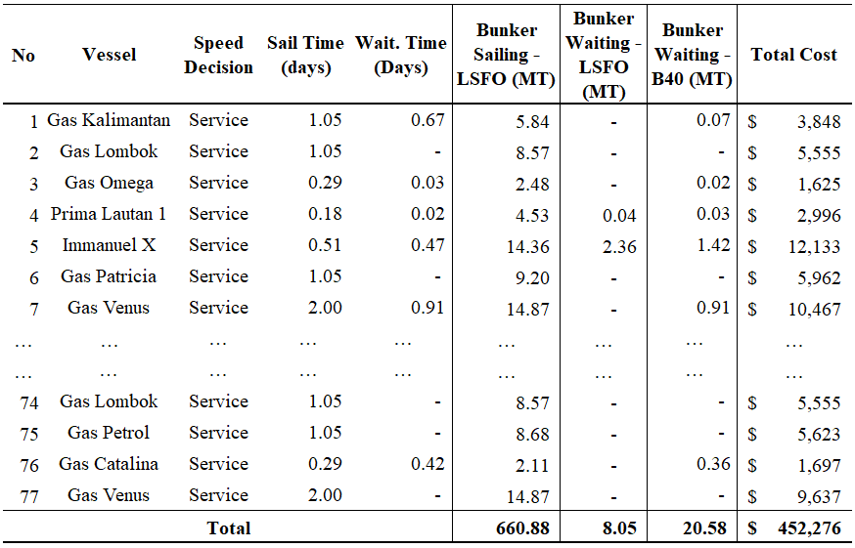

The next scenario involves the option of slow steaming. In this scenario, a decision must be made regarding whether to optimize service speed or slow steaming using MLIP, with the aim of minimizing total costs while satisfying existing constraints

Table 3
Cost calculation with slow steaming option
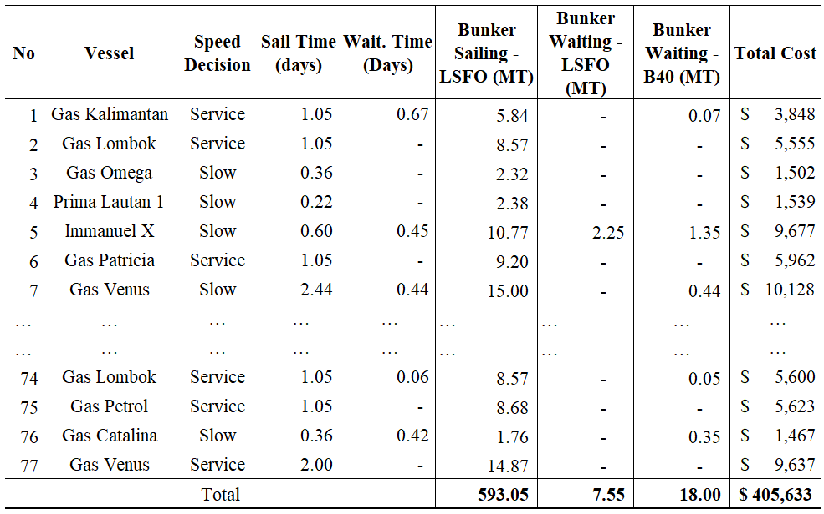

- Operation & Cost Analysis
From an operational perspective, the analysis compares sailing time and waiting time. Table 3 outlines the operational parameters for both the normal scenario and the slow steaming scenario. Implementing slow steaming results in longer sailing times for each vessel, as they operate at speeds below their standard service speed. However, as shown in Table 4, the decision to adopt slow steaming aims to reduce waiting times at Tanjung Sekong caused by jetty congestion; with this approach, the jetty waiting time is 3.26 days per month. This measure helps address one of the major waiting-time issues at TLPG Tanjung Sekong.

Table 4
Sailing and Waiting time comparison
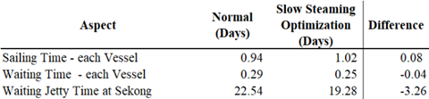

Comparison of bunker consumption and costs with the slow steaming option is presented in Table 5. As shown in the table, the slow steaming option offers potential savings on LSFO and B-40 bunkers. This is because the slow steaming option would be selected for vessels highly likely to face jetty waiting times; this reduces LSFO consumption during the voyage and minimizes the waiting time during which B-40 bunker is consumed. Implementing the slow steaming option presents a potential bunker cost saving of $46,675 per month, as indicated in Table 5

Table 5
Consumption and Total Cost Comparison
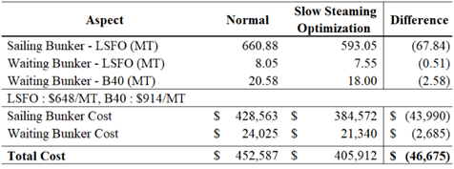

- Carbon Reduction.
Optimizing vessel speed through slow steaming offers potential carbon savings. This potential is derived from the reduced consumption of LSFO and B-40 bunker fuel, as shown in table 6. The carbon emission saving coefficients are 3.114 for LSFO and 3.48 for B-40. table 6 presents the calculation of carbon emission savings achieved through slow steaming. Based on these figures, the slow steaming method offers a potential carbon emission saving of 221.7 tons per month.

table 6
carbon reduction calculation
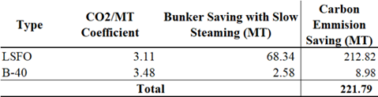

- Feasibility for Implementation via Vessel Speed Decision Support Framework (VSDSF)
The Vessel Speed Decision Support Framework (VSDSF) is proposed to integrate the optimization model into operational planning by supporting vessel speed decisions based on operational schedules, fuel consumption, bunker prices, estimated arrival time, and potential waiting time. The framework incorporates the model into the existing planning process, enabling re-optimization when operational conditions change while maintaining clear functional responsibilities. A phased implementation roadmap is introduced to facilitate pilot deployment, system integration, and continuous improvement, providing a practical pathway for organizational adoption of optimization-based vessel speed management.
- conclusion
This study demonstrates that the proposed Mixed Integer Linear Programming (MILP) model can effectively support vessel speed decisions for LPG transportation at Tanjung Sekong LPG Terminal by integrating sailing speed selection with berth availability and vessel operational constraints. The model minimizes total bunker cost while maintaining operational feasibility under actual terminal conditions. The optimization results indicate that implementing the recommended speed strategy reduces sailing and waiting bunker consumption, leading to monthly bunker cost savings of approximately USD 46,675. The optimized schedule also decreases vessel waiting time by 3.26 days per month and lowers estimated CO₂ emissions by 221.7 MT per month. These findings suggest that integrating speed optimization with berth scheduling can improve operational efficiency, reduce fuel expenditure, and support more sustainable LPG terminal operations.
Table 7
Summary of Conclusion
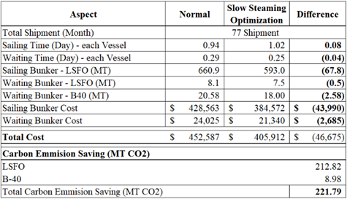

acknowledgements
The authors would like to express their sincere gratitude to Pertamina International Shipping and TLPG Tanjung Sekong Team, for providing the related data for this study. Special thanks are also extended to the supervisors whose continuous guidance, insightful feedback, and academic supervision have been invaluable throughout this research. The authors also thank all faculty members of Department of Marine Engineering, Marine Technology Faculty Institut Teknologi Sepuluh November for their encouragement and constructive discussions that helped refine the direction of this work.
The authors are profoundly grateful to their families for their unwavering support, patience, and understanding during the research process. Their moral encouragement provided the strength and motivation necessary to complete this study.

references

[1] UNCTAD, Manual on a uniform system of port statistics and performance indicators, 3rd editio. Geneva: United Nations Conference on Trade and Development (UNCTAD), 1987.
[2] H. N. Psaraftis and C. A. Kontovas, “Speed models for energy-efficient maritime transportation : A taxonomy and survey,” Transp. Res. Part C, vol. 26, pp. 331–351, 2013, doi: 10.1016/j.trc.2012.09.012.
[3] X. Bai, H. Jia, and M. Xu, “Port congestion and the economics of LPG seaborne transportation,” Marit. Policy Manag., vol. 00, no. 00, pp. 1–17, 2021, doi: 10.1080/03088839.2021.1940334.
[4] G. Fuentes, S. W. Wallace, and R. Adland, “The effects of waiting times on the bunkering decision for tramp ships,” Marit. Transp. Res., vol. 6, no. October 2023, p. 100106, 2024, doi: 10.1016/j.martra.2024.100106.
[5] K. Fagerholt, G. Laporte, and I. Norstad, “Reducing fuel emissions by optimizing speed on shipping routes,” J. Oper. Res. Soc., vol. 61, no. 3, pp. 523–529, 2009, doi: 10.1057/jors.2009.77.
[6] G. Brancaccio et al., “Investment in Infrastructure and Trade : The Case of Ports,” 2024.
[7] L. M. Hvattum and G. Laporte, “Analysis of an Exact Algorithm for the Vessel Speed Optimization Problem,” Networks, no. 1, 2013, doi: 10.1002/net.
[8] M. Ng, “Vessel speed optimisation in container shipping : A new look,” J. Oper. Res. Soc., vol. 5682, pp. 1–7, 2018, doi: 10.1080/01605682.2018.1447253.
[9] J. F. Alvarez, T. Longva, and E. S. Engebrethsen, “A methodology to assess vessel berthing and speed optimization policies,” Marit. Econ. Logist., vol. 12, no. 4, pp. 327–346, 2010, doi: 10.1057/mel.2010.11.
[10] J. Yu, G. Tang, and X. Song, “Collaboration of vessel speed optimization with berth allocation and quay crane assignment considering vessel service differentiation,” Transp. Res. Part E, vol. 160, no. March, p. 102651, 2022, doi: 10.1016/j.tre.2022.102651.
[11] S. Guo, H. Wang, and S. Wang, “Managing port disruption through sailing speed optimization for sustainable maritime transportation,” Clean. Logist. Supply Chain, vol. 11, no. March, p. 100153, 2024, doi: 10.1016/j.clscn.2024.100153.
[12] X. Wen, Q. Chen, Y. Yin, and Y. Lau, “Multi-Objective Optimization for Ship Scheduling with Port Congestion and Environmental Considerations,” 2024.
[13] A. Fan et al., “Review of speed optimisation for ship energy efficiency : methods , taxonomy and challenges,” vol. 354, no. July, pp. 1–7, 2026.
[14] T. Zhou, Q. Hu, Z. Hu, and J. Zhi, “Theory and Application of Vessel Speed Dynamic Control considering Safety and Environmental Factors,” vol. 2022, 2022, doi: 10.1155/2022/5333171.

