HYDRAULIC MODELING STUDY OF ALTERNATIVE FLOOD CONTROL STRATEGIES FOR THE REJOSO RIVER PASURUAN
Mohammad Dimas Noor Syamsuddin¹, Mahendra Andiek Maulana²
¹Department of Civil Engineering, Institut Teknologi Sepuluh Nopember, Surabaya, Indonesia
E-mail: dimasnos21@gmail.com

Received: June 5, 2025 | Accepted: September 17, 2025 | Published: October 1, 2025
DOI: 10.12962/j27745449.v6i1.4525 | Issue: Volume 6 Number 1 2025 | E-ISSN: 2774-5449

ABSTRACT
Rejoso River is administratively included in Pasuruan Regency where its watershed is located in 10 sub-districts (Puspo, Tosari, Gondang Wetan, Rejoso, Winongan, Pasrepan, Grati Districts of Pasuruan Regency and Lumbang, Sukapura, Probolinggo Regency). The area of the Rejoso River watershed is ± 361.2 km², bordered by hillsides and protected forests. In general, the cause of flooding in the Rejoso River watershed is caused by high intensity rainfall and changes in land use such as the Rejoso River, especially in the upstream area. The flat topography of the downstream area causes potential sedimentation which inhibits the flow (run off). The purpose of this study is to determine the condition of the existing system and capacity of the Rejoso River; to determine the influence of land use, and to provide alternative scenarios for the most effective flood control to reduce the flood water level or collect the flood that occurs. In this study, hydrological and hydraulic modeling was carried out. The method that used in the calculation of flood discharge is HEC-HMS, while for hydraulic analysis the HEC-RAS 1D is used with the results of water level at the river cross section. This analysis aims to determine the most effective flood control scenario for reducing flooding that occurs in the Rejoso River. The results of this study are alternative flood control scenarios for the Rejoso River by carrying out normalization, embankments structure and retention ponds which are the best scenarios for reducing high flood water levels. This can be shown by a decrease of average height of the flood water level from 1.207 meters to 0.435 meters. With these conditions, it can be concluded that this scenario is the best scenario for reducing the high flood overflow in the Rejoso River.
Keyword: Rejoso Watershed, Hydrograph, Flood, Rejoso River, Flood Control

Introduction
In general, the cause of flooding in the Rejoso River watershed is due to high intensity rainfall and changes in land use along the Rejoso River, especially in the upstream area [1-3]. The flat topography of the downstream area causes potential sedimentation which inhibits the flow (Run off), the influence of the ebb and flow of sea water in the estuary area and the overflowing of drainage channels/avor/tributaries that flow into the Rejoso River due to garbage, water gates that are not functioning properly and the influence of the ebb and flow itself [1][4]. In order to solve these problems, an alternative flood control is needed [5-7]. It is hoped that the results of this study can be used as a reference to reduce the impact of flooding that occurs in several villages and sub-districts passed by the Rejoso River.
According to the latest report from the Pasuruan Regency Communications and Information Agency, flooding occurred in March 2024, affecting three sub-districts: Grati, Winongan, and Rejoso [8].
According to records from the Pasuruan Regency Regional Disaster Management Agency (BPBD), the worst flooding occurred in Kebrukan Hamlet, Kedawung Kulon Village, Grati District. In this area, floodwaters reached 1-2 meters high due to the lowland conditions of the community, forming a depression. In addition, floods in Grati District also infiltrated residential areas in Kedawung Wetan Village. Meanwhile, floods in Winongan District was occurred in five villages, Prodo, Bandaran, Winongan Kidul, Lebak, and Sruwi. Among these villages, Bandaran Village was the worst affected, where floodwaters reached 1.30 meters [9].
In the other hands, four villages that located in the Rejoso District (Toyaning, Arjosari, Rejoso Lor, and Jarangan) were experienced severe floods which Toyaning village become the most largest impacted.
In order to solve this problem, an alternative flood control is needed [5-7]. It is hoped that the results of this study can be used as a reference to reduce the impact of flooding that occurs in several villages and sub-districts through which the Rejoso River flows.

Methodology
The stages carried out in compiling this research are as follows:
Hydrology Analysis
In carrying out this hydrological analysis, 10 (ten) rainfall stations were used spread across the Rejoso River Basin with 10 years of duration from 2014 to 2023. In this study, flood discharge was used with a return period of 25 years using HEC HMS program [10].
This study will use the Soil Conservation Service (SCS) unit hydrograph. The SCS unit hydrograph model is a single-peaked and dimensionless hydrograph [10].
The model simulation phase includes model setup and model running. Model setup is the step of entering several parameters into the model. The parameters that used for HEC HMS model are the sub-watershed area, initial abstraction, curve number, imperviousness, and time lag [10].
Model calibration is performed to determine the model's success in representing river discharge. The calibration is performed by comparing measured and simulated discharge using the Nash-Sutcliffe model efficiency coefficient (NSE) [12]. Calibration was performed until the model showed a Nash-Sutcliffe coefficient (NSE) greater than 0.50 [12]. The results of this HEC HMS modeling study are a comparison of simulated and observed discharges in the Rejoso River, as well as the calculated peak flood discharge [10].
Flood Modeling Analysis
The HEC-RAS 2D numerical/mathematical approach model was created and developed by the Hydraulic Engineering Center, a division of the Institute for Water Resources (IWR), U.S. Army Corps of Engineers [11]. This program is part of the Next Generation (NextGen) development of Hydrologic Engineering software. HEC-RAS 2D essentially consists of 3 (three) components of (one) dimensional hydraulic analysis (one dimensional computation), namely:
- One-dimensional steady flow simulation.
- One-dimensional unsteady flow simulation.
- Sediment movement transport calculation.
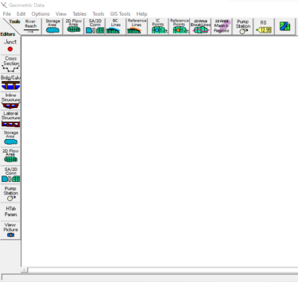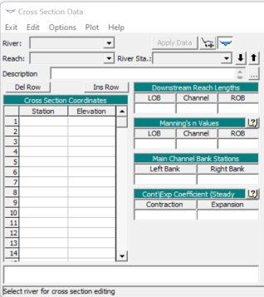
Figure 1. Channel Geometry Data Editing Menu
A hydraulic analysis using the HEC RAS program was conducted to assess the impact of flood discharge on the Rejoso River's capacity. The analysis involved 1D modeling using direct topographic measurement data [11].
The modeling was conducted from upstream to downstream in flood-prone areas, based on information from the East Java Provincial Public Works and Water Resources Agency and the surrounding community, which experiences flooding almost annually in the study area [13].
Flood Control Scenarios
The development of alternative flood control scenarios aims to identify effective solutions for mitigating flood risks. These scenarios are designed based on specific locations and combined according to local field conditions [13]. The proposed alternatives are as follows:
- Alternative 1: River normalization
- Alternative 2: River normalization combined with embankment or parapet construction
- Alternative 3: River normalization combined with the construction of a retention pond
- Alternative 4: River normalization combined with embankment or parapet construction and a retention pond.

Result and Discussion
Rainfall Analysis
The Thiessen Polygon method is used to obtain the maximum annual regional average rainfall. All of rainfall station that located in Rejoso watershed are evaluated. Furthermore, it is necessary to divide the area or area of the rainfall station so that the area of influence by each observed rainfall station is obtained [1][2]. Table 1 shows the magnitude of the area of influence on each rainfall station and its coefficient of influence.
Table 1. Thiessen Coefficient Table Based on Area
Rainfall Station | Area |  | Thiessen  Coefficient
Gading | 72.15 | km² | 0.20
Kawisrejo | 17.60 | km² | 0.05
Kedawung | 54.93 | km² | 0.15
Kwd Grati | 13.96 | km² | 0.04
Lumbang | 9.86 | km² | 0.03
Panditan | 82.57 | km² | 0.23
Puspo | 5.91 | km² | 0,02
Ranugrati | 21.04 | km² | 0,06
Umbulan | 28.53 | km² | 0,08
Winongan | 54.40 | km² | 0,15
Total | 360.95 | km² | 1,00
After calculating the maximum annual regional rainfall using the Thiessen Polygon, an analysis of the design rainfall that occurred in the Rejoso Watershed was then carried out.
Table 2. Design Rain Values Using Several Methods
No | Tr | Rainfall Design (mm)
No | Tr | Normal | Log Normal | Gumbel | Pearson
1 | 1.05 | 32.397 | 35.338 | 30.192 | 27.007
2 | 2 | 57.276 | 55.239 | 55.109 | 55.841
3 | 5 | 70.018 | 69.441 | 74.193 | 70.525
4 | 10 | 76.693 | 78.283 | 86.828 | 79.188
5 | 15 | 79.424 | 82.216 | 93.957 | 82.398
6 | 25 | 83.191 | 87.970 | 102.792 | 89.215
7 | 50 | 88.374 | 96.550 | 114.636 | 96.128
8 | 100 | 92.621 | 104.202 | 126.392 | 102.622
9 | 200 | 96.414 | 111.545 | 138.105 | 108.824
10 | 1000 | 104.150 | 128.169 | 165.237 | 122.436
From the recapitulation table above, it is concluded that the most appropriate distribution to use is the Pearson Log III Distribution because it has the smallest D value and is accepted in both Distribution Tests.
After conducting a frequency distribution suitability test, a rainfall intensity calculation was carried out to obtain the volume of rainfall per unit of time using the hourly rainfall formula of the Mononobe Model. The calculation uses a rainfall duration of 6 hours, because the rainfall concentration time in Indonesia is 5-7 hours (Limantara 2010). To obtain the effective rainfall value, it is necessary to multiply the hourly rainfall ratio by the design rainfall (Rn) in mm and multiply it by the value of the rainfall runoff coefficient (C) of the Rejoso Watershed of 0.5. Then the effective rainfall height is obtained for each hour in a 6-hour time interval and at a 25-year return period of 43.28 mm/hour, as in Table 3.
Table 3. Distribution of Effective Rainfall Height Hourly Mononobe Model of Rejoso Watershed
Hour | Return Period (yr)
Hour | 2 | 5 | 10 | 25
1 | 11.41 | 16.81 | 20.04 | 23.82
2 | 2.97 | 4.37 | 5.21 | 6.19
3 | 2.08 | 3.06 | 3.65 | 4.34
4 | 1.66 | 2.44 | 2.91 | 3.46
5 | 1.40 | 2.06 | 2.46 | 2.92
6 | 1.22 | 1.80 | 2.15 | 2.55
Daily Rainfall Probability | 55.84 | 70.52 | 79.19 | 89.21
Flow coefficient | 0.5 | 0.5 | 0.5 | 0.5
Effective Rainfall | 20.73 | 30.54 | 36.41 | 43.28
HEC HMS Modelling
The calculation of flood discharge in this study uses the HEC-HMS auxiliary program. Calculations with the HEC-HMS auxiliary program are carried out by creating a modeling of the Rejoso watershed network system, namely the depiction of the water catchment area model (basin model) and entering input in the form of rainfall data, land use, and so on. The depiction of the water catchment area model can be seen in Figure 2.
The calculation of the planned flood discharge is carried out using the HEC-HMS auxiliary program, where in the HEC-HMS modeling the SCS-CN (Soil Conservation Service - curve number) runoff calculation method is used.
In this study on the sub basin parameter Loss Method using SCS Curve Number, Transform Method using SCS Unit Hydrograph. Scenario for routing is done using 3 methods namely SCS CN, Lag, and Impervious. This process resulted flow discharge which observed in the AWLR Sidepan on January 16, 2025.
The HEC HMS model results provide a peak discharge around 146.60 m³/s. In the other hands, the peak discharge from AWLR observations was recorded at 122.80 m³/s. Hence, the calibration using Nash-Sutchlife provide value of 0.373.
After the modeling results are obtained, parameter calibration is needed to obtain the closest parameter optimization. Optimization uses the (trial and error) method by changing several parameters, namely Curve Number, Initial Abstraction, and Impervious.

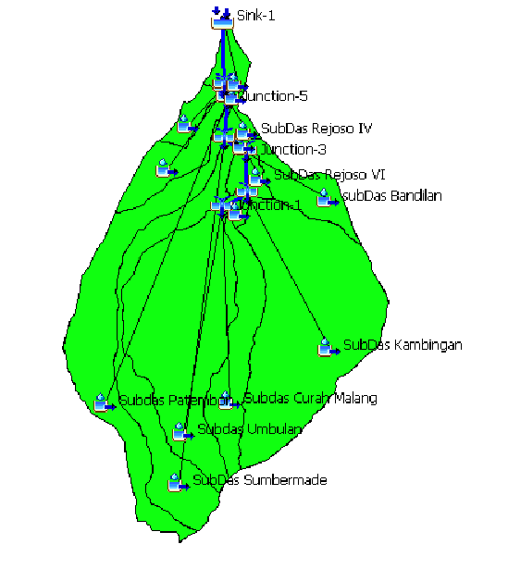
Figure 2. Rejoso watershed hydrology model with HEC HMS Program
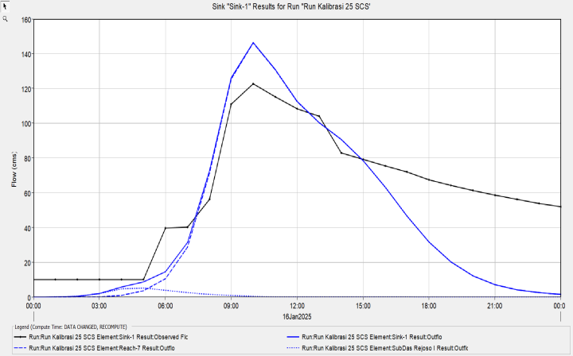
Figure 3. Design Flood Discharge Hydrograph and AWLR Discharge at 25th Return Period
The results obtained from optimization using HEC HMS then obtained the largest NSE value of 0.448 in optimization in the Malang Curah sub-basin. So, the discharge that will be used for HEC RAS modeling is the model discharge in optimization of 145.4 m³/sec.
HEC RAS Modelling
The Rejoso River modeling starts from the input of Rejoso River geometry data for flood simulation that taken from river measurements. This data included 14.234 km of river length from the estuary to the confluence of the Umbulan River and Curahmalang River tributaries.
After the hydrological calculation, the hydraulic analysis will be assisted by using the Hec-Ras program, then the data produced shows that there is a flood overflow on the Rejoso River. The flood overflow occurs in many sections from downstream to upstream of the Rejoso River which can be seen in the longitudinal profile of the Rejoso River.
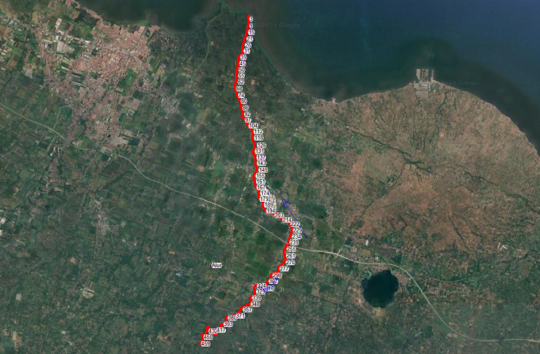
Figure 4. HEC RAS Modeling Scheme of Rejoso River
Figure 5. Longitudinal section water surface profile of Rejoso River channel Existing Condition
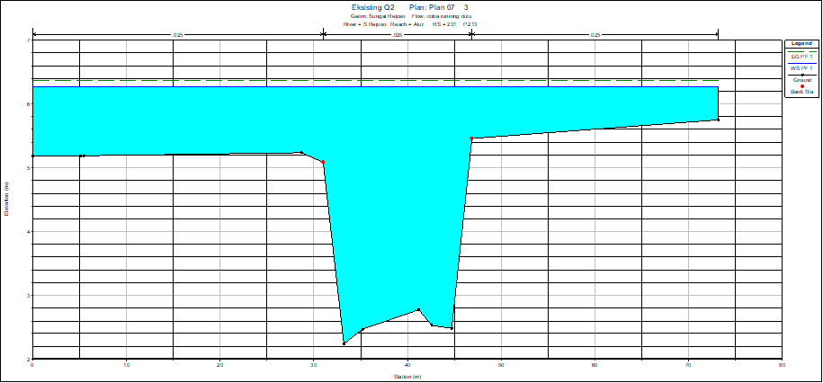
Figure 6. Design Flood Discharge Hydrograph and AWLR Discharge at 25th Return Period
The results of HEC RAS model with the existing condition obtained an average overflow water level of 1.2 meters at 408 points of the right embankment and 321 points of the left embankment.

Based on field identification, these results are in accordance with the flood events that have occurred in several locations affected by the Rejoso River flood with inundation heights ranging from 0.3 to 1 meter.
To provide the best flood management, several scenarios are prepared as follows:
- Alternative 1: River Normalization
- Alternative 2: River Normalization + Parapet
- Alternative 3: River Normalization + Retention Pond
- Alternative 4: Normalization + Parapet + Retention Pond
After the analysis, the following results were obtained.
Table 4. Recapitulation of Alternative Results of Flood Management Scenarios
Scenario | Existing Water Level | Water Level after Treatment | Difference | Reduction
Scenario | (m) | (m) | (m) | (%)
1 | 1.21 | 0.72 | 0.49 | 40.17
2 | 1.21 | 0.44 | 0.77 | 63.62
3 | 1.21 | 0.71 | 0.49 | 40.96
4 | 1.21 | 0.44 | 0.77 | 63.93
From the table above, it is known that the planned scenarios are able to reduce the height of the flood overflow that occurs in the Rejoso River. The results of several analyses that have been carried out show that scenario 4 is an alternative scenario that is able to overcome flooding better than the other four scenarios. This is indicated by a decrease in the height of the flood overflow from 1.207 meters to 0.435 meters with a percentage decrease in the water level from the existing condition of 63.933%.
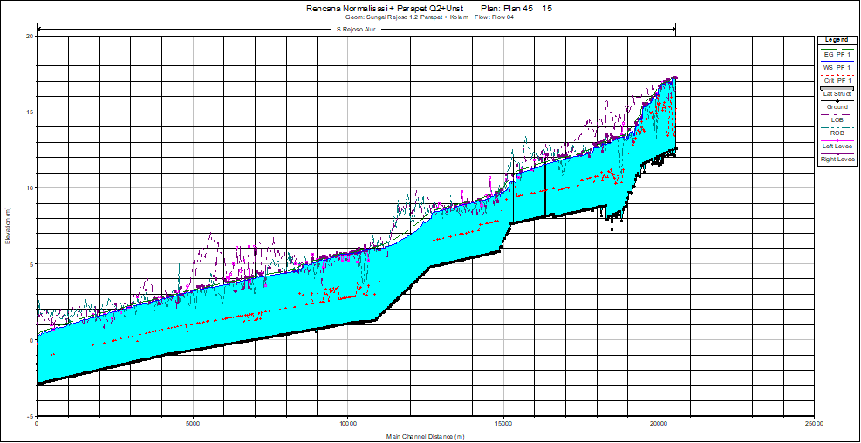
Figure 7. Longitudinal water surface profile of Rejoso River Scenario 4
Figure 8. Cross-sectional water surface profile of Rejoso River Scenario 4

Conclusion
Through a hydrological analysis of the Rejoso Watershed conducted with the Hec HMS program using the SCS method, a 25-year design flood discharge of 145.5 m³/second was obtained.
Hydraulic analysis of the Rejoso River using the HEC RAS revealed that the existing Rejoso River is unable to accommodate a 25-year return period of flood (145.5 m³/s), with an average inundation height of 1.207 meter, and an overflow of 408 meters and 321 meter of length on the right and left embankment respectively.
Each scenario reduced flood discharge with varying results. It concluded that scenario 4 was the most effective in managing flooding compared to the other scenarios.

Acknowledgements
The author wishes to extend profound appreciation to the Institut Teknologi Sepuluh Nopember for their generous support and invaluable contributions to this research. The provision of resources, facilities, and technical assistance, as well as the opportunity to conduct this study under their guidance, were essential to the successful completion of this work.

References
- R.K. Linsley, J.B. Franzini, D. Sasongko, Teknik Sumber Daya Air, Erlangga, Jakarta, 1991.
- N. Hadisusanto, Aplikasi Hidrologi, Jogja Media Utama, Yogyakarta, 2011.
- Indarto, Hidrologi Dasar dan Teori dan Contoh Aplikasi Model Hidrologi, Bumi Aksara, Jakarta, 2010.
- I. Subarkah, Hidrologi untuk Perencanaan Bangunan Air, Idea Darma, Bandung, 1980.
- B. Akbar, Kajian Pengendalian Banjir Sistem Sungai Alophu Kabupaten Gorontalo Propinsi Gorontalo, Universitas Brawijaya, Malang, 2009.
- R. Fauziah, Pengendalian Banjir Menggunakan Pompa (Studi Kasus: Drainase Jalan Simpang Tetap Kota Dumai), Universitas Riau, Pekanbaru, 2015.
- G. Idfi, Skenario Kolam Retensi Untuk Menurunkan Debit Puncak Banjir Kali Ngotok, Institut Teknologi Sepuluh Nopember, Surabaya, 2017.
- Pemerintah Kabupaten Pasuruan, Banjir Terjang 11 Desa di Kabupaten Pasuruan, Pasuruan, 2024. Available from:

https://www.pasuruankab.go.id/isiberita/banjir-terjang-11-desa-di-kabupaten-pasuruan
- Badan Nasional Penanggulangan Bencana (BNPB) & BPBD Kabupaten Pasuruan, Indonesia: Flooding in Pasuruan (East Java), March 2024, ReliefWeb/ADInet, Jakarta, 2024. Available from: https://reliefweb.int/report/indonesia/indonesia-flooding-pasuruan-east-java-16-mar-2024
- U.S. Army Corps of Engineers, Hydrologic Modeling System HEC-HMS, User’s Manual, Hydrologic Engineering Center, Davis, California, 2021.
- U.S. Army Corps of Engineers, HEC-RAS River Analysis System 2D Modeling User’s Manual, Version 6.0, Hydrologic Engineering Center, Davis, California, 2021.
- M. Nash, Efficiency of use of hydrologic models, Journal of Hydrology, 27(3–4), pp. 282–290, 1975.
- East Java Provincial Public Works and Water Resources Agency, Flood Control and River Basin Management Report, Surabaya, 2023.

